AI Smart Attendance System
Day-3 Task Submission: Face Recognition Library Test & Accuracy Notes

Data Safety Compliance: Only the public-domain LFW (Labeled Faces in the Wild) dataset was used for this test. No real student photos or personally identifiable data were uploaded to GitHub or used in testing.
1. Objective
Test the face_recognition library on a small sample dataset to check whether it can correctly match two different photos of the same person, and record the observed result as a qualitative accuracy note — not a statistical accuracy percentage, since full dataset testing has not yet been completed.
2. Setup
Environment: Google Colab (used to avoid local dlib/Windows installation issues encountered during setup).
- Installed dependency: face_recognition (dlib-based, 128-dimension face encoding)
- Dataset: LFW (Labeled Faces in the Wild) — loaded via sklearn.datasets.fetch_lfw_people
- Selected one person (Aaron Peirsol) with multiple available photos in the dataset
- Saved two different photos of this person as known_face.jpg and test_face.jpg
3. Test Code
known_image = face_recognition.load_image_file("known_face.jpg")
known_encoding = face_recognition.face_encodings(known_image)
test_image = face_recognition.load_image_file("test_face.jpg")
test_encoding = face_recognition.face_encodings(test_image)
result = face_recognition.compare_faces([known_encoding[0]], test_encoding[0])
distance = face_recognition.face_distance([known_encoding[0]], test_encoding[0])

4. Execution Output
Colab output — Same person match: 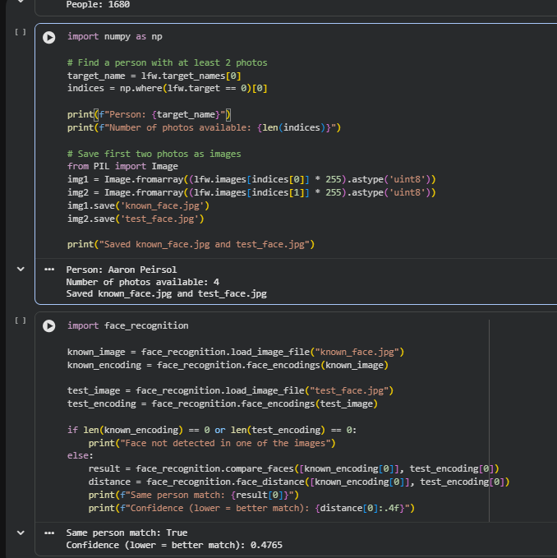True, Confidence: 0.4765
5. Result Summary
Field | Value
Dataset used | LFW (Labeled Faces in the Wild) — public research dataset
Person tested | Aaron Peirsol (4 photos available in dataset)
Images compared | known_face.jpg vs test_face.jpg (2 different photos, same person)
Library | face_recognition (dlib-based, 128-d encoding)
Same person match | True
Confidence (distance) | 0.4765 (lower = better match)

6. Observations
face_recognition correctly identified two different photos of the same person as a match, with a distance score of 0.4765 (well under the typical 0.6 threshold used by the library for a positive match). This indicates the library's encoding-based approach is capable of recognizing identity across photo variation (different pose/expression) for this sample.
This result is a single-sample qualitative test, not a statistical accuracy measurement. A proper accuracy percentage requires testing across many people and multiple photos per person, which will be done once the actual student dataset is available. No project-specific accuracy claim is being made at this stage.
7. Next Steps
- Expand testing to multiple people from the dataset to observe match consistency.
- Test a 'different person' pair to confirm the library correctly returns False (no match).
- Once the real student dataset is ready, run full accuracy testing (true positive / false positive rates) before finalizing the recognition pipeline.

